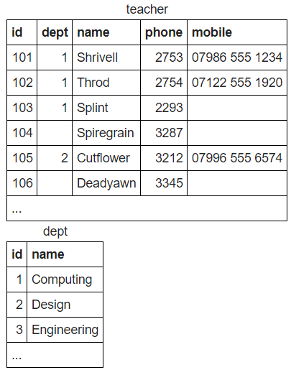



**SELECT name FROM teacher WHERE dept IS NULL**



**SELECT teacher.name, dept.name FROM teacher INNER JOIN dept WHERE (teacher.dept=dept.id)**



**SELECT teacher.name, dept.name FROM teacher LEFT JOIN dept WHERE (teacher.dept=dept.id)**



**SELECT teacher.name, dept.name FROM teacher RIGHT JOIN dept ON (teacher.dept=dept.id)**

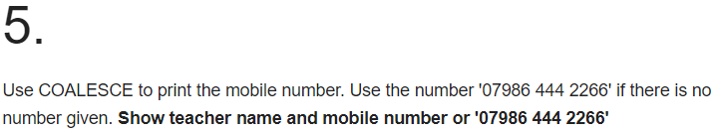

**SELECT name, COALESCE(mobile, '07986 444 2266') FROM teacher**

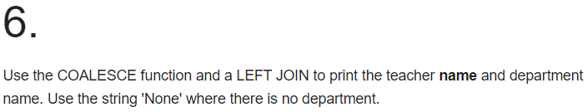

**SELECT COALESCE(teacher.name, 'NONE'), COALESCE(dept.name, 'None') FROM teacher LEFT JOIN dept ON (teacher.dept=dept.id)**

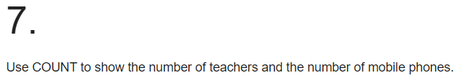

**SELECT COUNT(name), COUNT(mobile) FROM teacher**

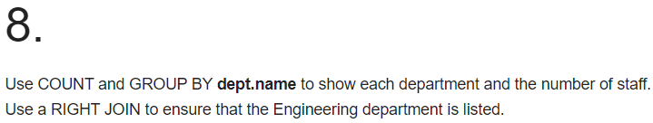

**SELECT dept.name, COUNT(teacher.name) FROM teacher RIGHT JOIN dept ON (teacher.dept=dept.id) GROUP BY dept.name**

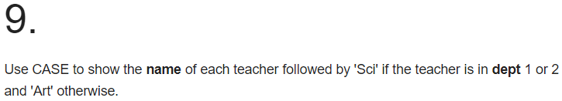

**SELECT teacher.name,**

**CASE WHEN dept.id = 1 THEN 'Sci'**

**WHEN dept.id = 2 THEN 'Sci'**

**ELSE 'Art' END**

**FROM teacher LEFT JOIN dept ON (teacher.dept=dept.id)**

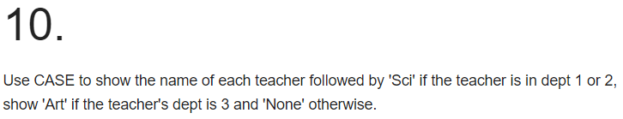

**SELECT teacher.name,**

**CASE**

**WHEN dept.id = 1 THEN 'Sci'**

**WHEN dept.id = 2 THEN 'Sci'**

**WHEN dept.id = 3 THEN 'Art'**

**ELSE 'None' END**

**FROM teacher LEFT JOIN dept ON (dept.id=teacher.dept)**